**TITLE OF LAB: (INTRODUCTION TO SINUSOIDAL SIGNALS)**

**LAB # 06**



**Spring 2022**

**CSE301L Signals & Systems Lab**

Submitted by: **Safi Ullah Khan**

Registration No.: **20PWCSE1943**

Class Section: **B**

“On my honor, as student of University of Engineering and Technology, I have neither given nor received unauthorized assistance on this academic work.”

Student Signature: ______________

Submitted to:

**Engr. Durr-e-Nayab**

Day, Date (e.g Sunday, Jun 05th, 2022)

**Department of Computer Systems Engineering**

**University of Engineering and Technology, Peshawar**

**OBJECTIVES OF THE LAB**

‐‐‐‐‐‐‐‐‐‐‐‐‐‐‐‐‐‐‐‐‐‐‐‐‐‐‐‐‐‐‐‐‐‐‐‐‐‐‐‐‐‐‐‐‐‐‐‐‐‐‐‐‐‐‐‐‐‐‐‐‐‐‐‐‐‐‐‐‐‐‐‐‐‐‐‐

* In this lab, we will cover the following topics:
* Generating Sinusoids
* Addition of Sinusoids with Variation in Parameters and their Plots
* Linear Phase Shift Concept When Dealing with Sum of Sinusoids

‐‐‐‐‐‐‐‐‐‐‐‐‐‐‐‐‐‐‐‐‐‐‐‐‐‐‐‐‐‐‐‐‐‐‐‐‐‐‐‐‐‐‐‐‐‐‐‐‐‐‐‐‐‐‐‐‐‐‐‐‐‐‐‐‐‐‐‐‐‐‐‐‐‐‐‐

**-------------------------TASK 01--------------------------**

* Generate the 1x10 row vector *v* whose *i*‐th component is cos (iπ/4).

**Screenshot of Input:**

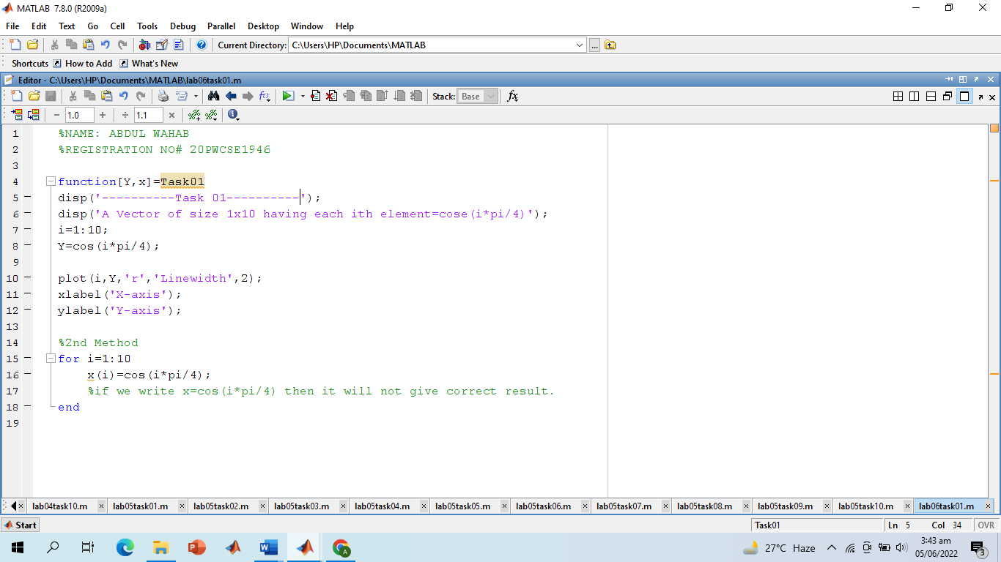

**Screenshot of Output:**

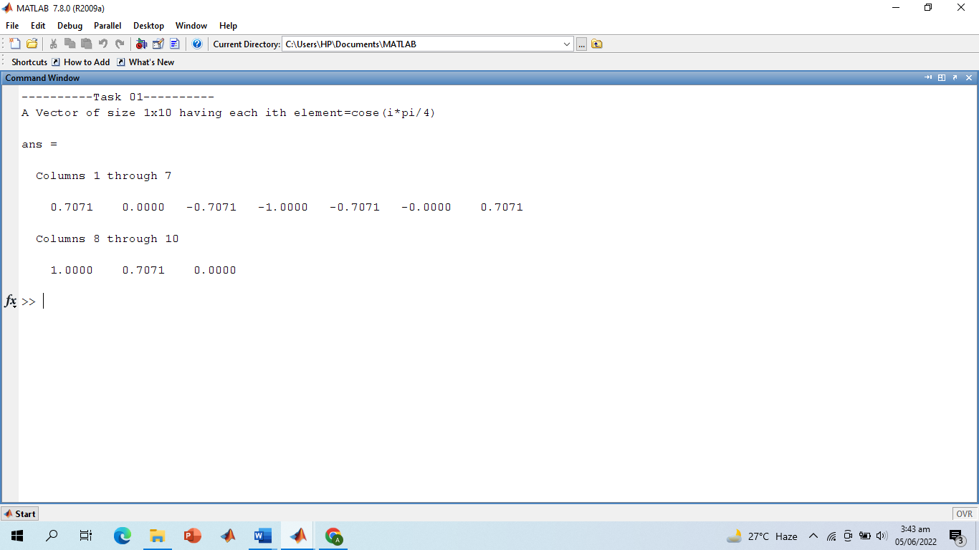

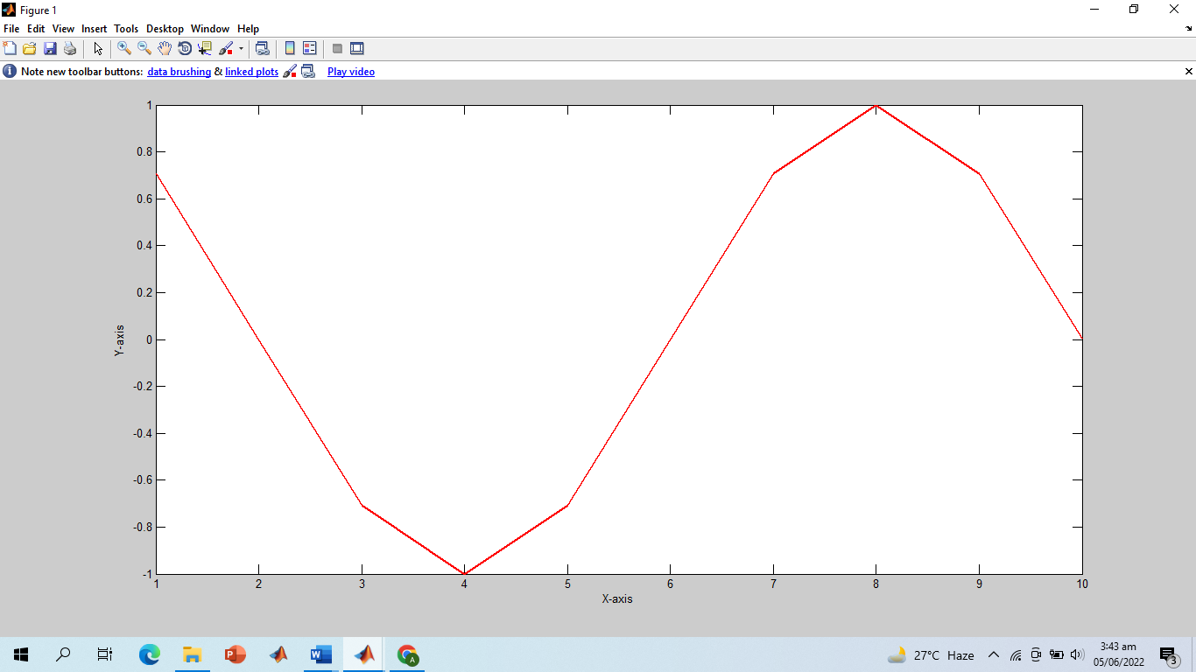

**-------------------------TASK 02--------------------------**

* Write matlab code that draw graphs of sin (nπx) on the interval ‐1≤x≤1 for n = 1, 2, 3, …, 8. (Hint: Use for loop)

**Screenshot of Input:**

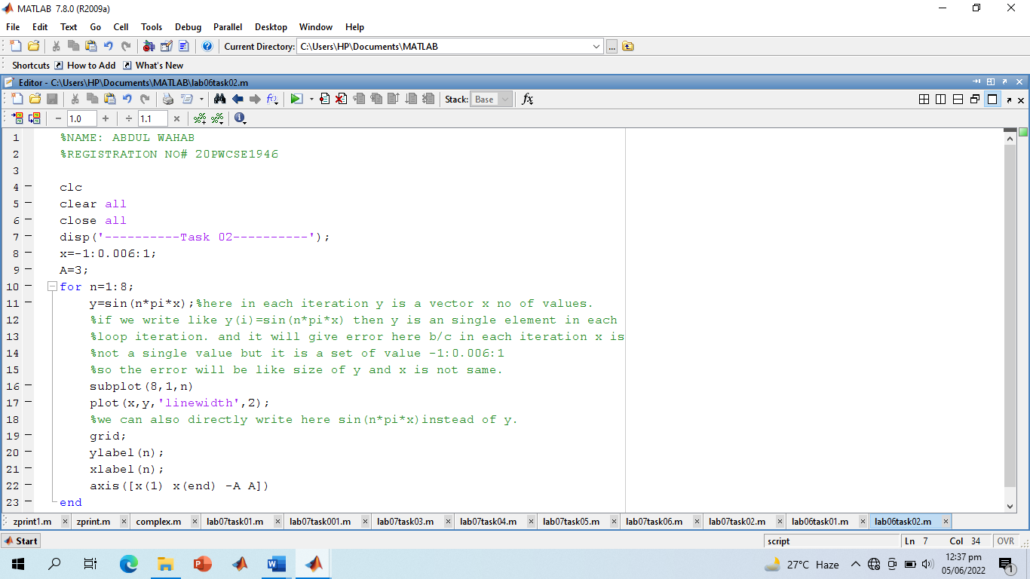

**Screenshot of Output:**

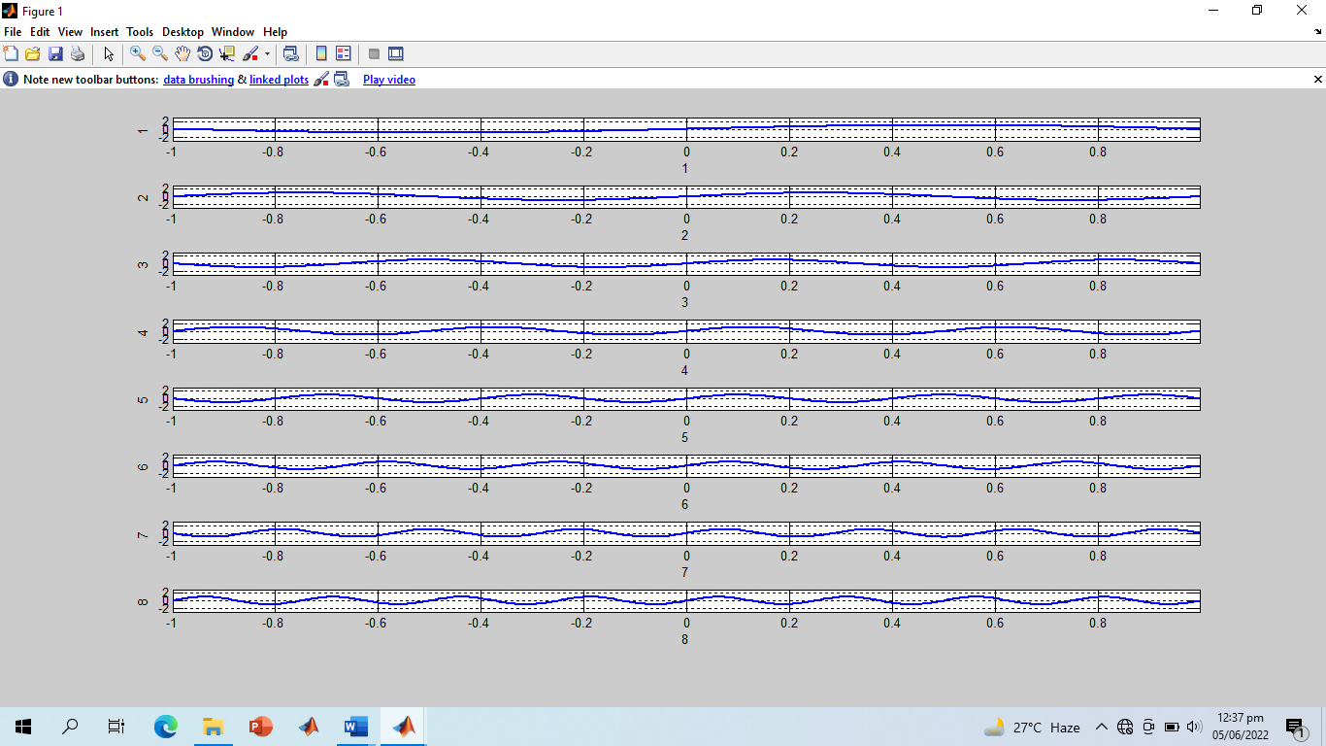

**-------------------------TASK 03--------------------------**

* Given the signal exp(‐x)sin(8x) for 0≤x≤2π, plot its continuous‐time and discrete‐time representations. Use subplot and label properly.

**Screenshot of Input:**

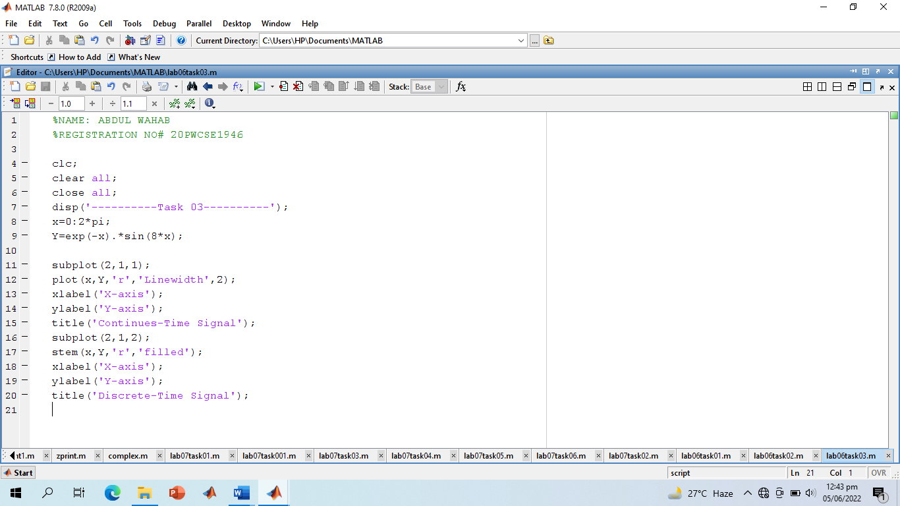

**Screenshot of Output:**

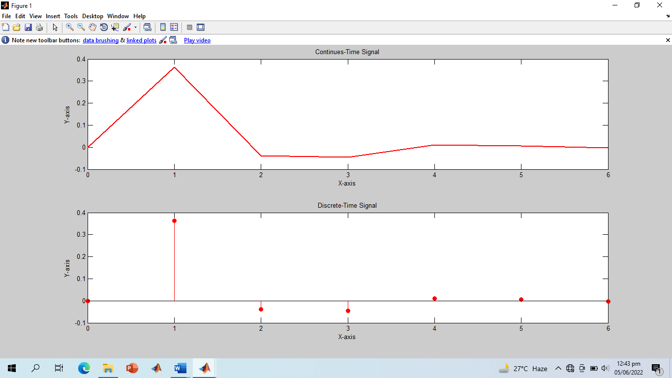

**-------------------------TASK 04--------------------------**

* Modify the example given in topic 6.2 to generate a sine wave with phase shift of +pi/2. Then plot a cosine wave of same frequency, amplitude, and phase shift of 0 in another subplot. Compare both the signals and determine the relationship between the two.

**Screenshot of Input:**

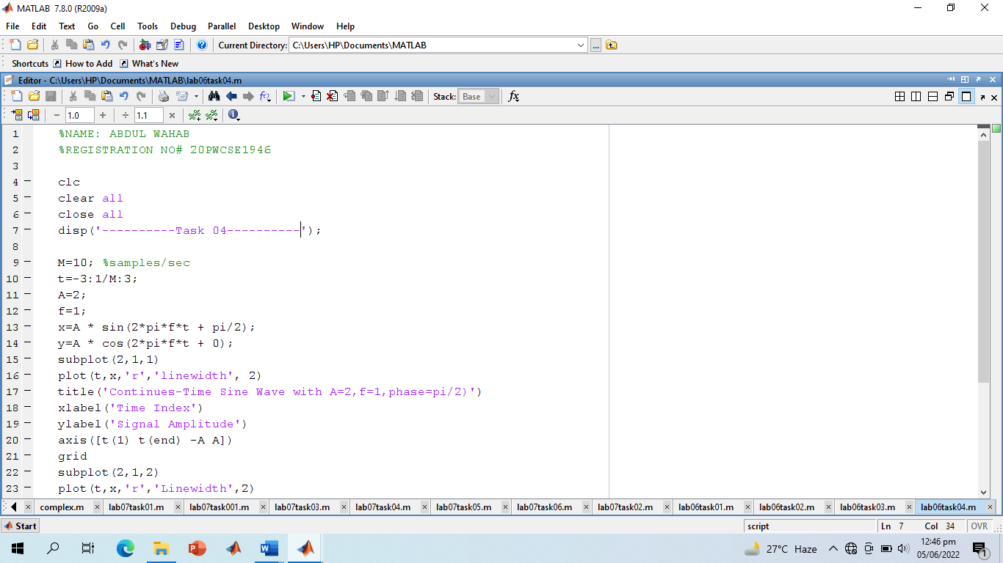

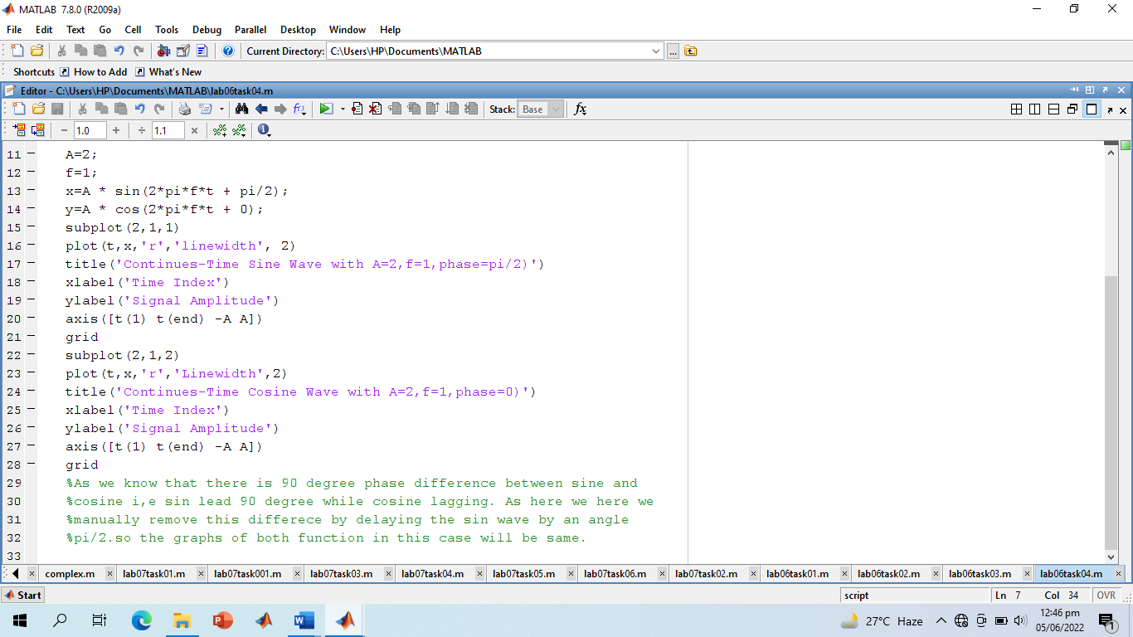

**Screenshot of Output:**

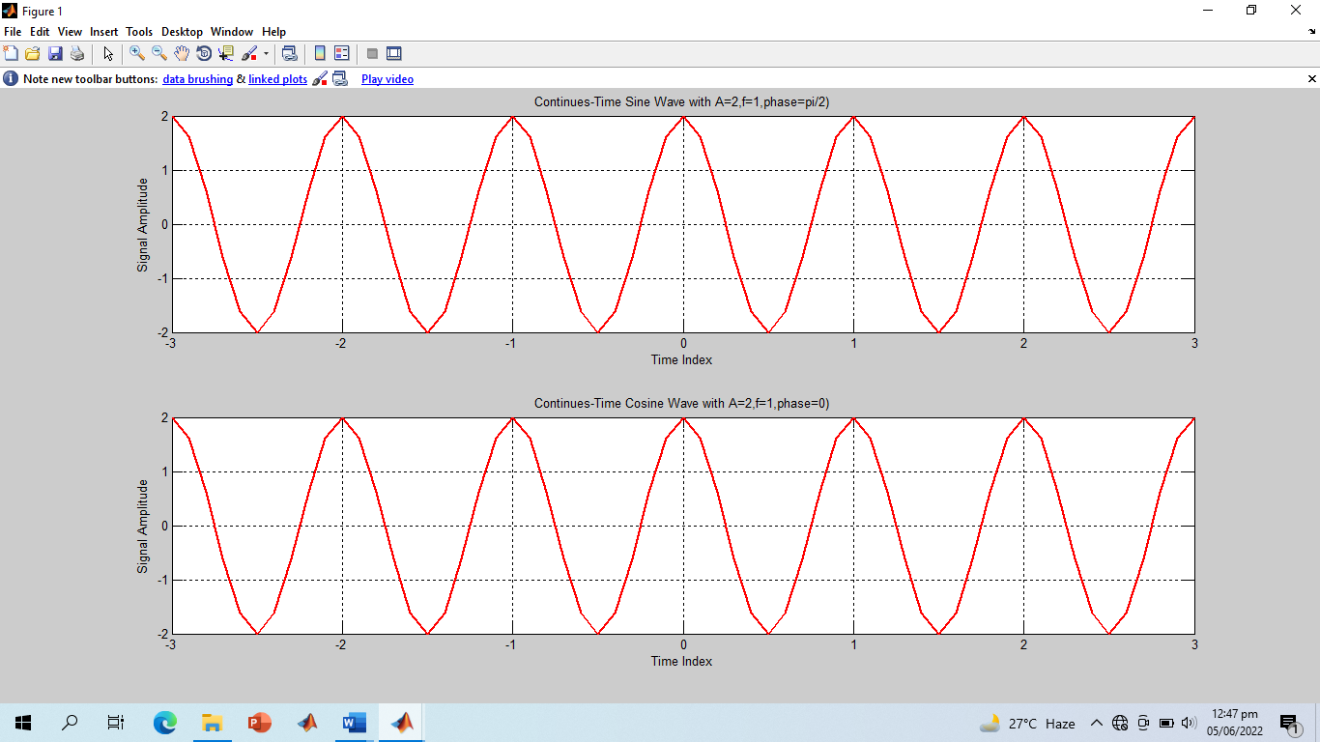

**-------------------------TASK 05--------------------------**

* Write a program to generate a continuous‐time sine wave of frequency 3 Hz, positive phase shift of pi/2, and amplitude of 5. Also generate a continuous‐time cosine wave of frequency 3 Hz, amplitude of 5, and phase shift of 0. Plot the two signals on separate subplots and properly label them. Determine the relationship between the two signals.

**Screenshot of Input:**

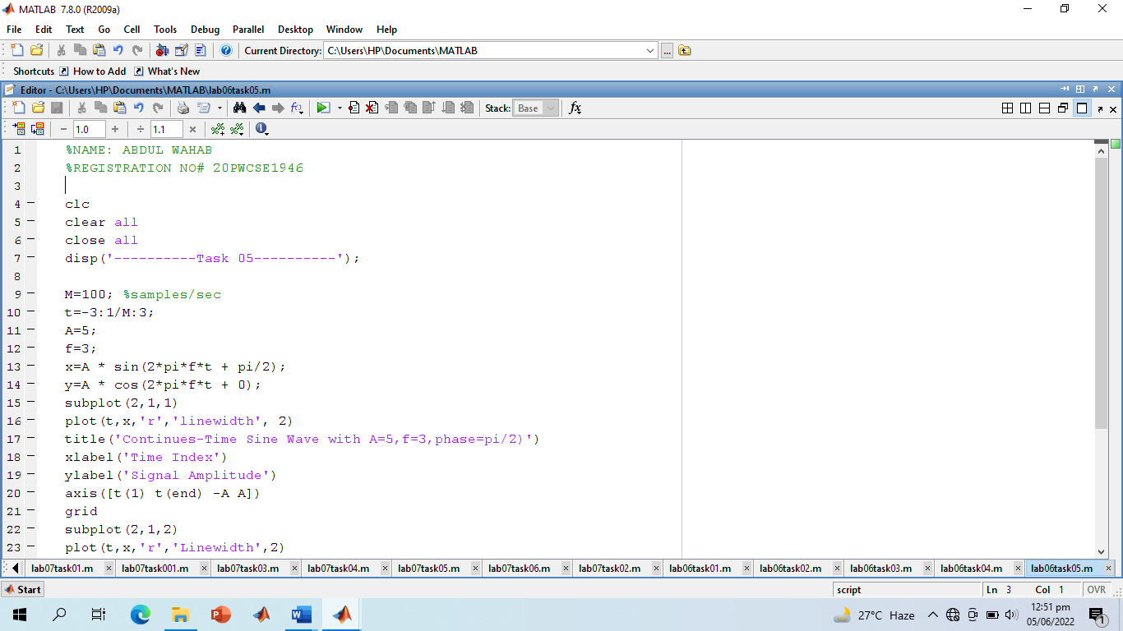

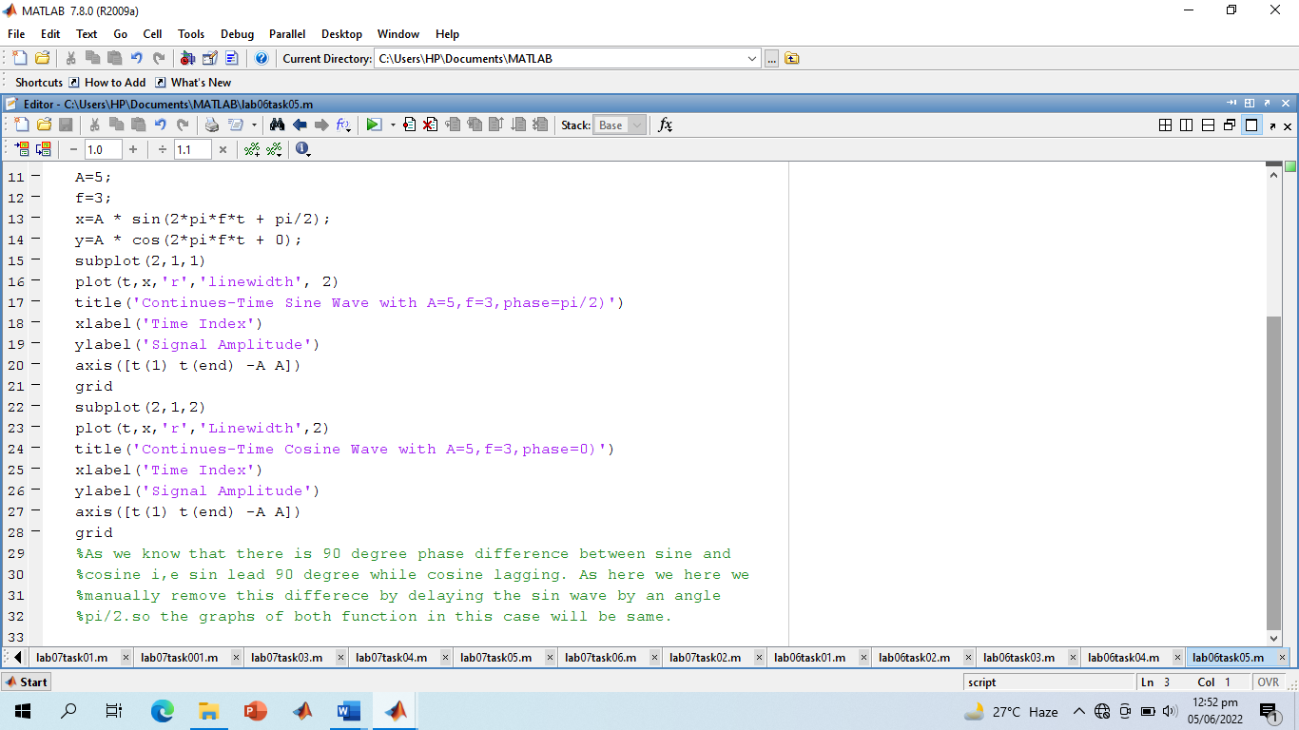

**Screenshot of Output:**

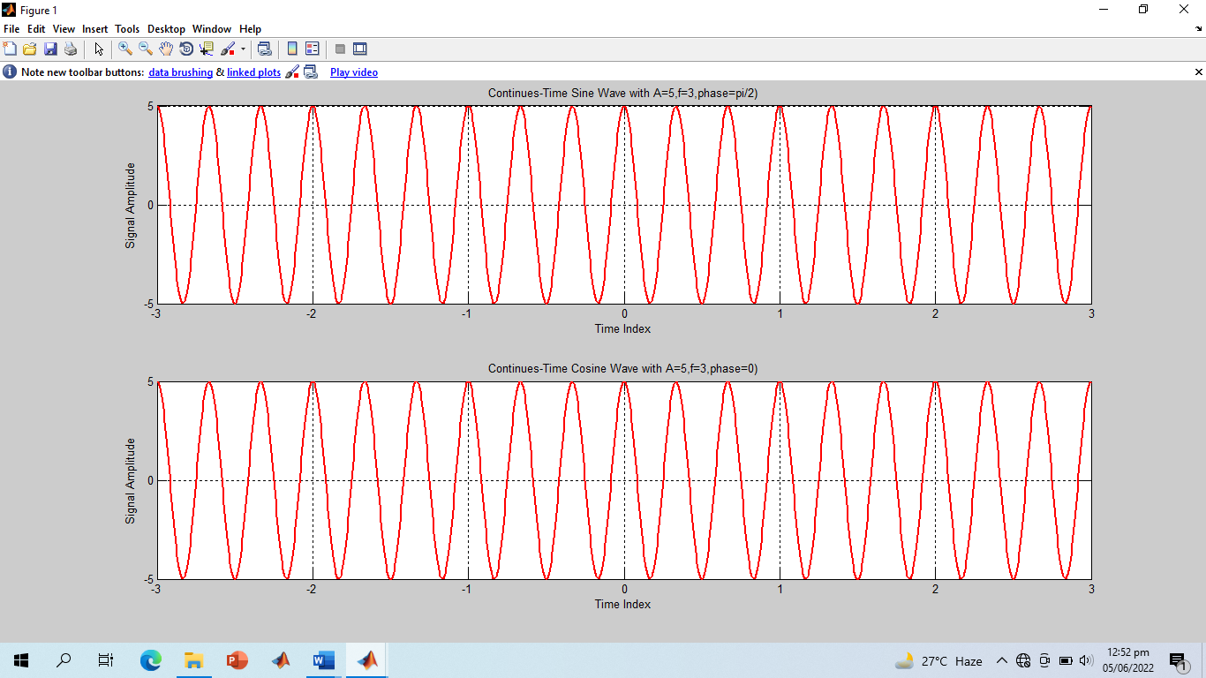

**-------------------------TASK 06--------------------------**

* Write a general program that takes ‘n’ sinusoids from user of same frequency, amplitude, and phase. Plot the individual sinusoids & the resultant using subplot function on same figure. Do perform proper labeling. Note: Take the amplitude, frequency, and phase given in example of case 1. Run the code for different values of n and state the result on paper

**Screenshot of Input:**

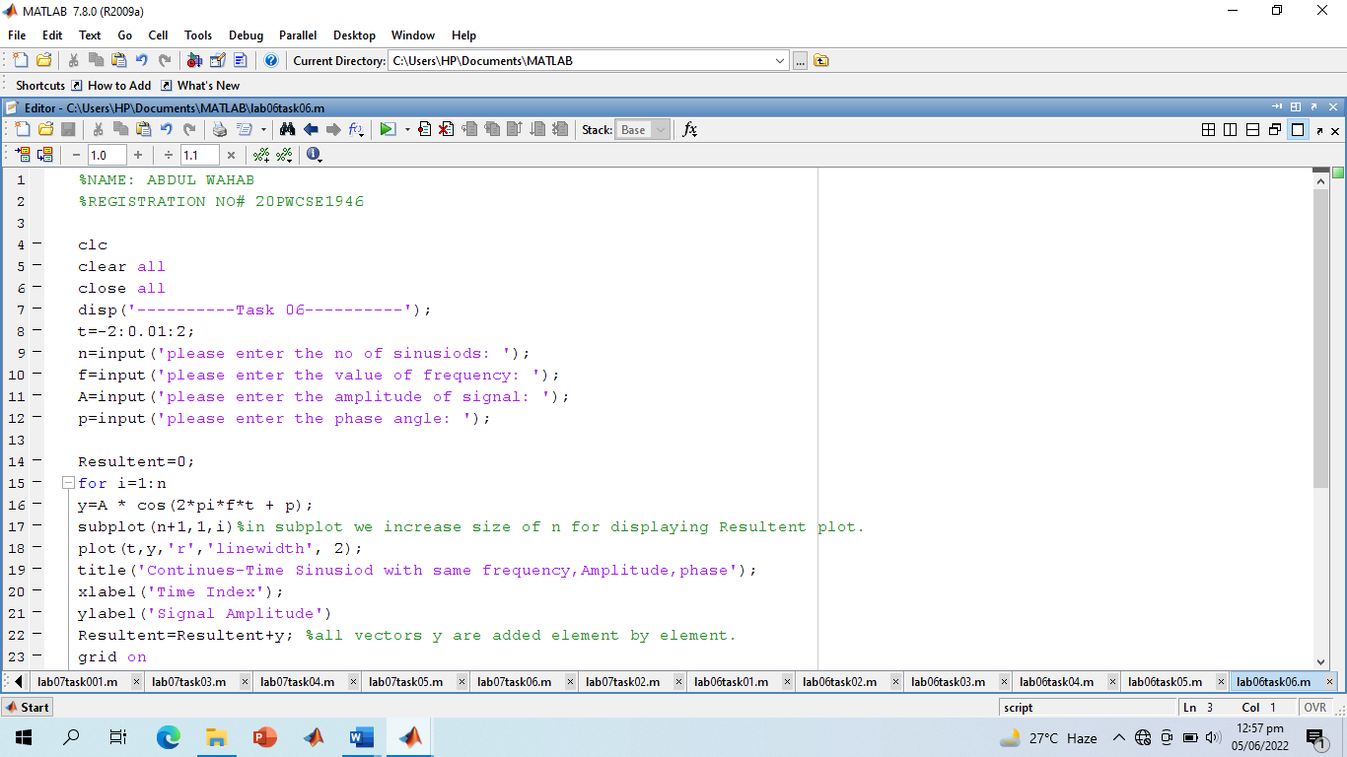

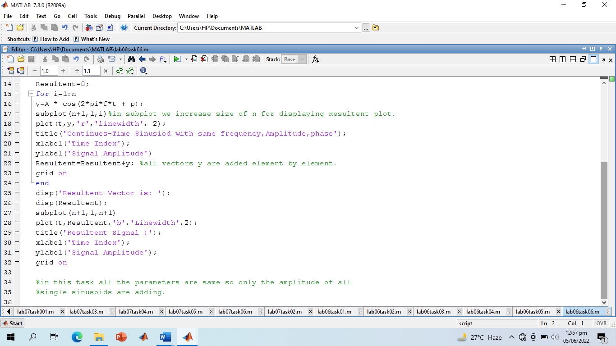

**Screenshot of Output:**

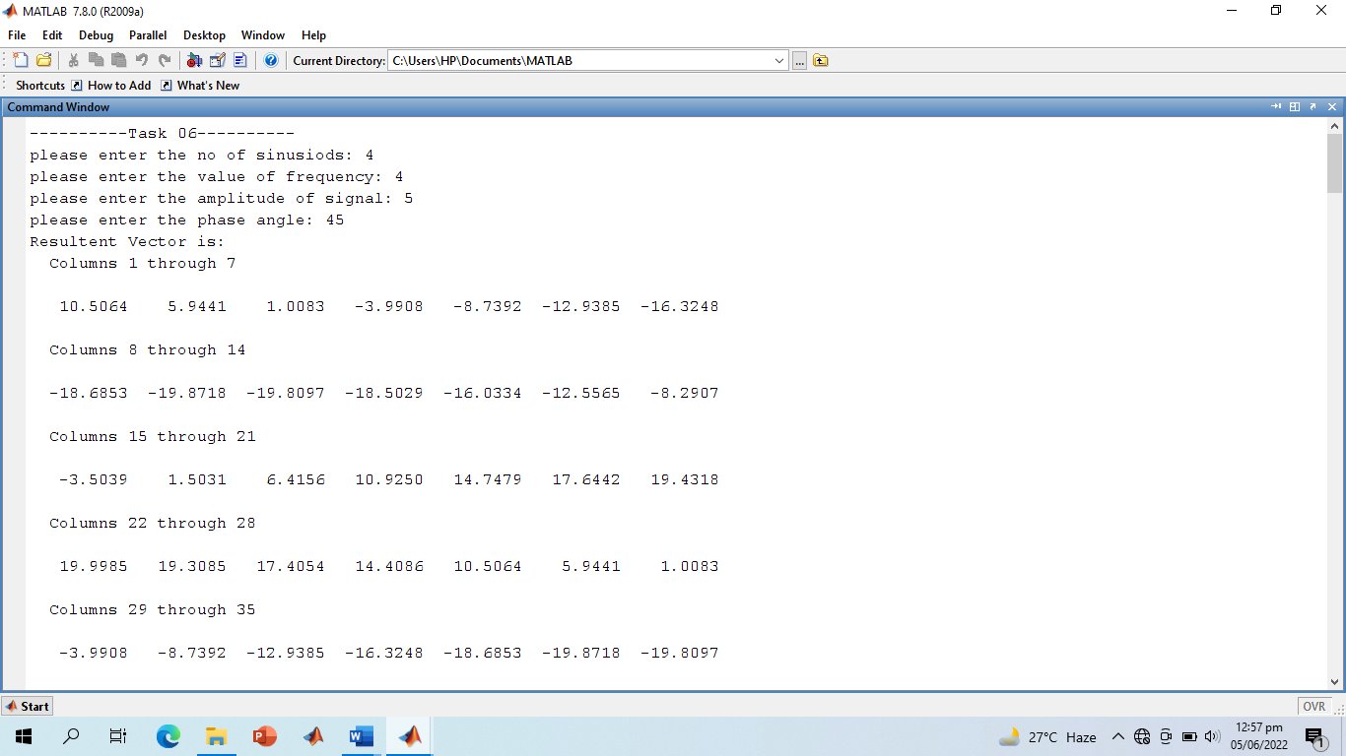

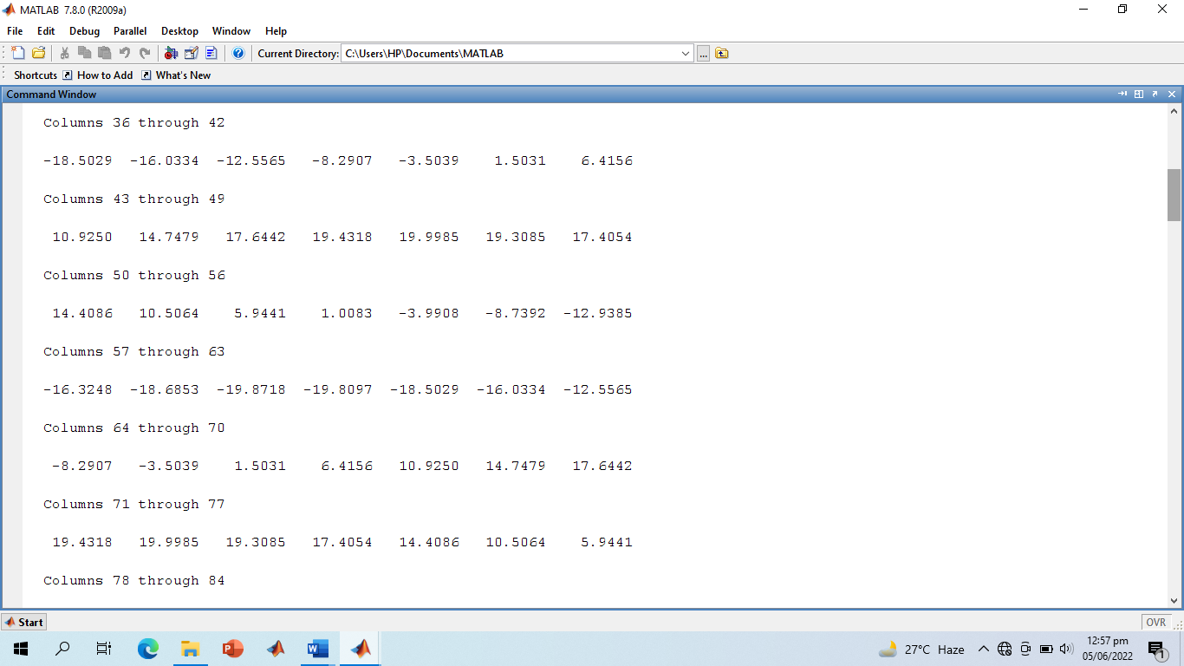

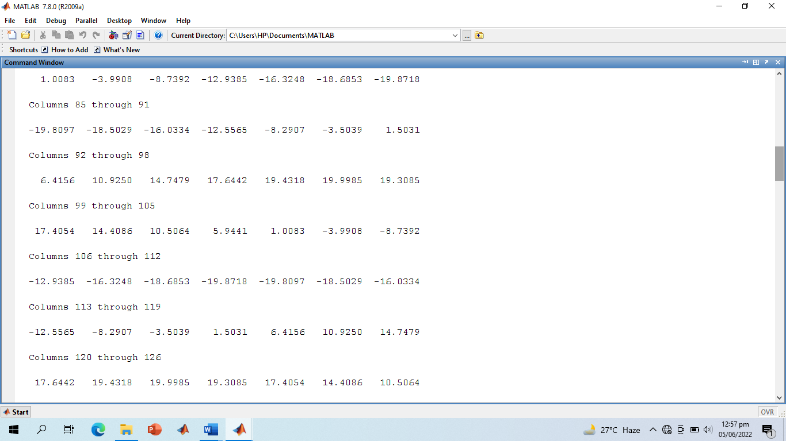

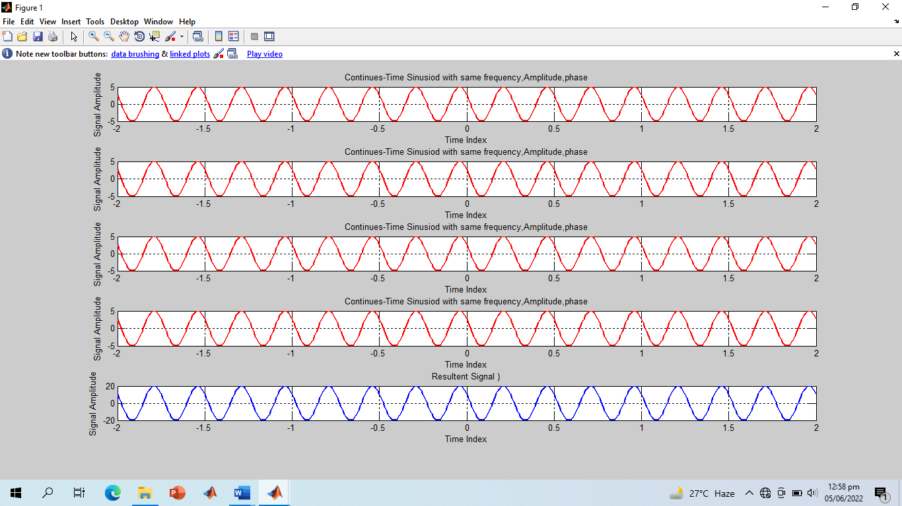

**-------------------------TASK 07--------------------------**

Write a general program that takes ‘n’ sinusoids from user of same frequency, amplitude, and phase. Plot the individual sinusoids & the resultant using subplot function on same figure. Do perform proper labeling. Note: Take the amplitude, frequency, and phase given in example of case 1. Run the code for different values of n and state the result on paper.

**Screenshot of Input:**

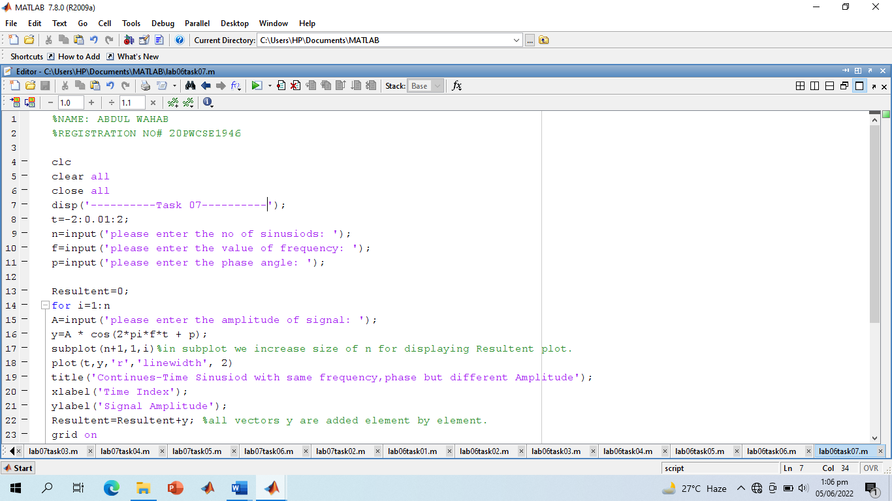

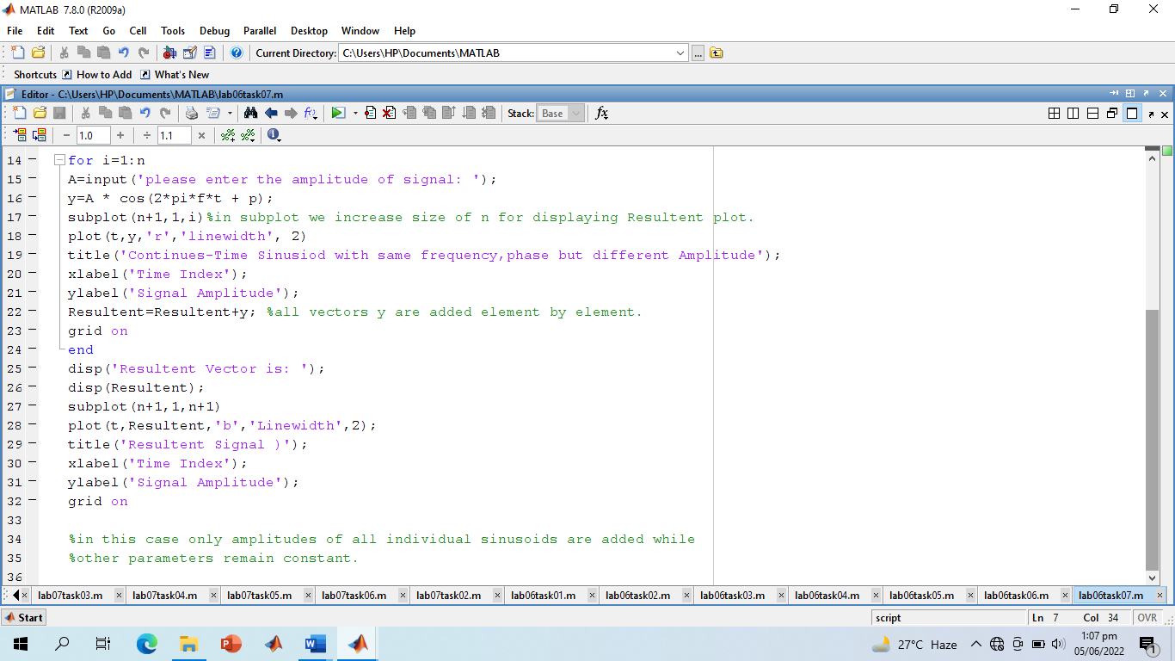

**Screenshot of Output:**

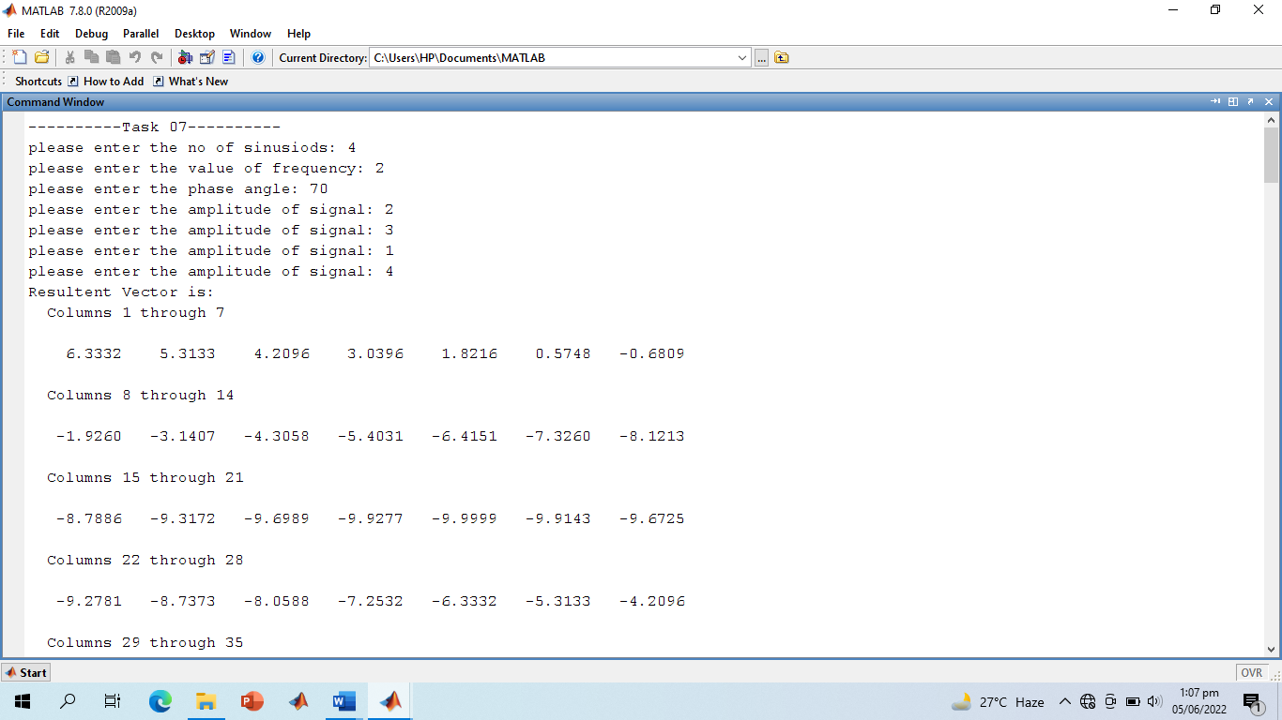

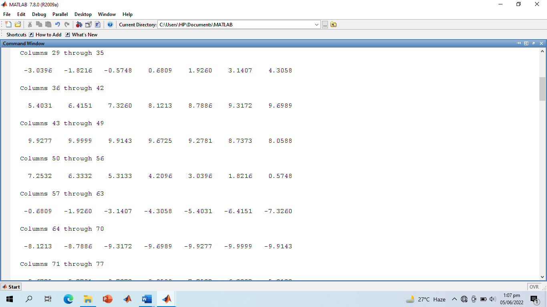

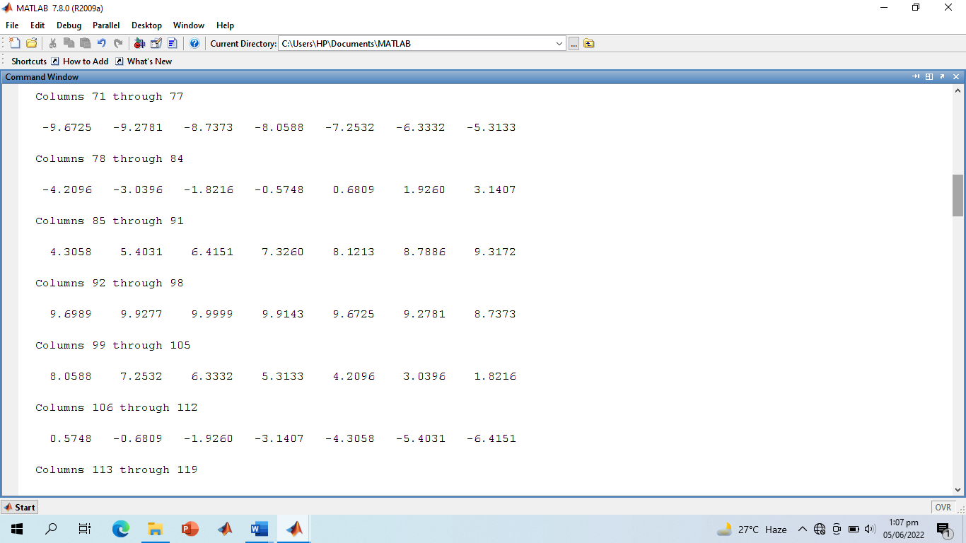

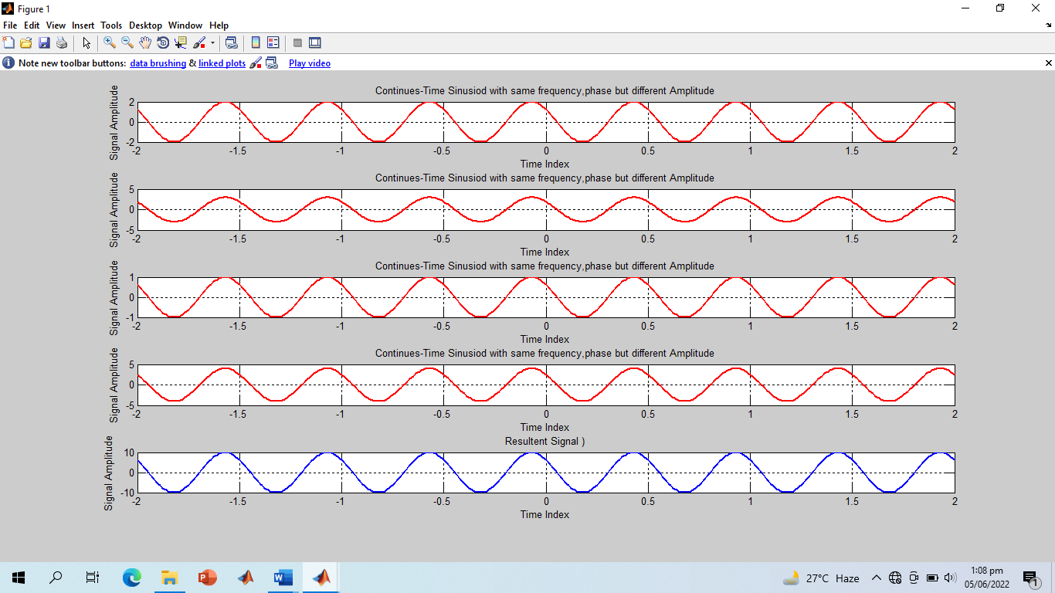

**-------------------------TASK 08--------------------------**

* Write a general program that takes ‘n’ sinusoids from user of same amplitude and phase with varying frequencies. Take each frequency from user on run time. Plot the individual sinusoids & the resultant using subplot function on same figure. Do perform proper labeling. Note: Take the amplitude and phase given in example of case 3. Run the code for different values of n and state the result on paper.

**Screenshot of Input:**

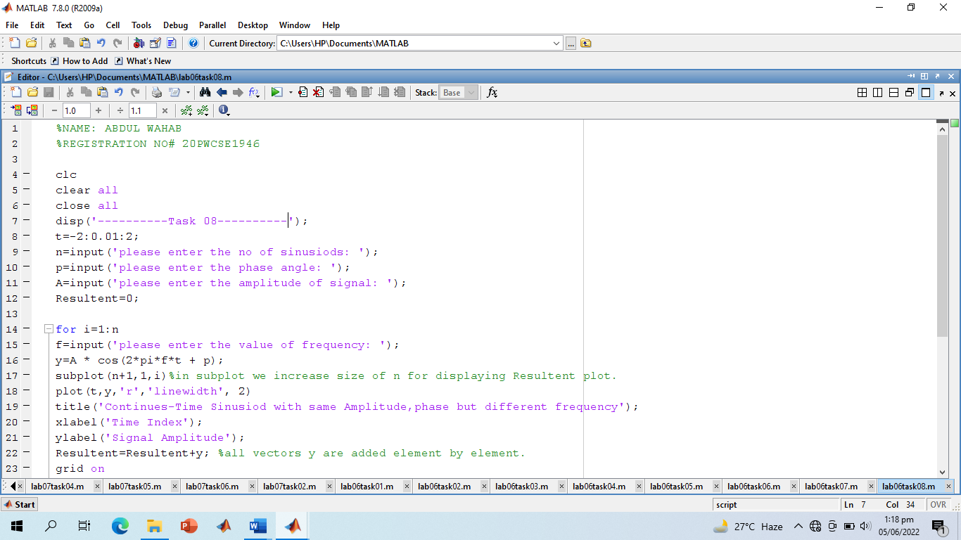

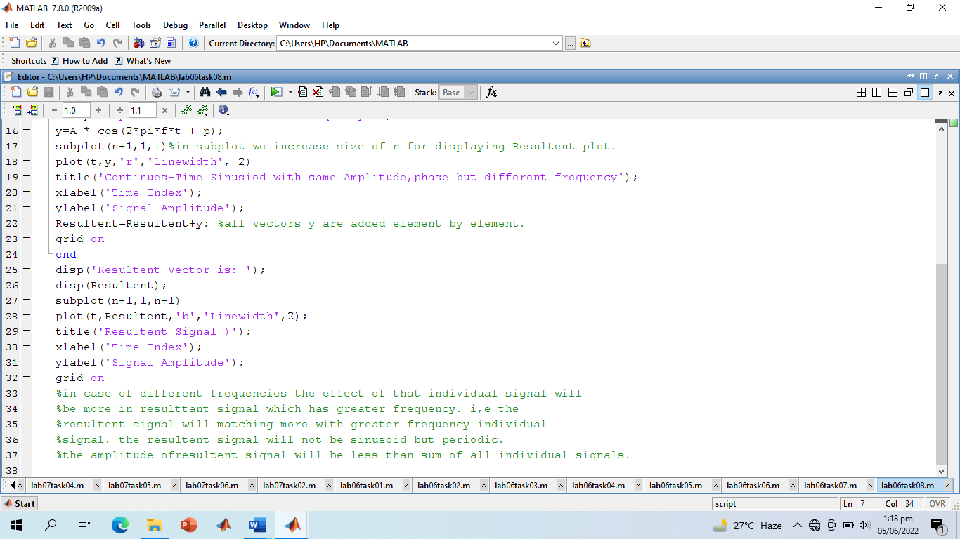

**Screenshot of Output:**

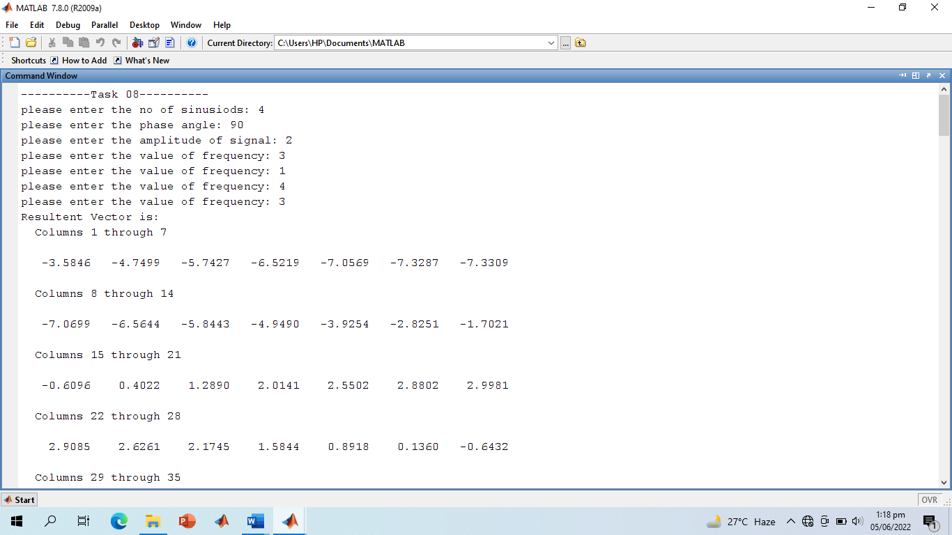

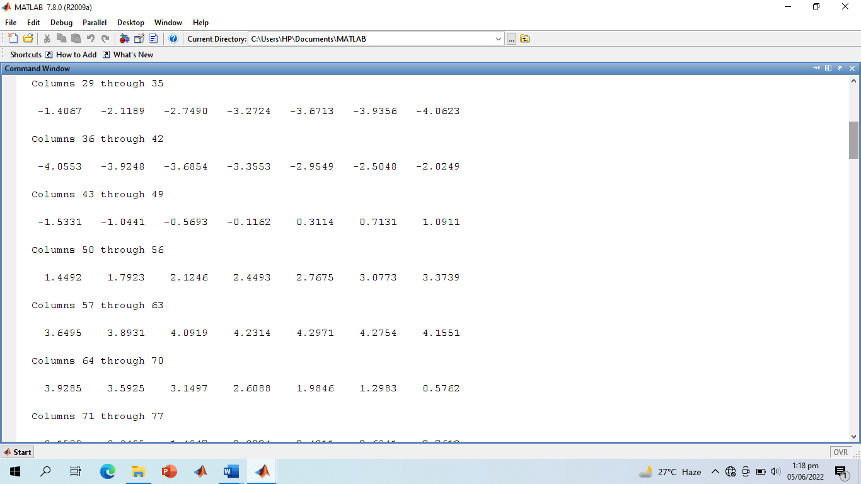

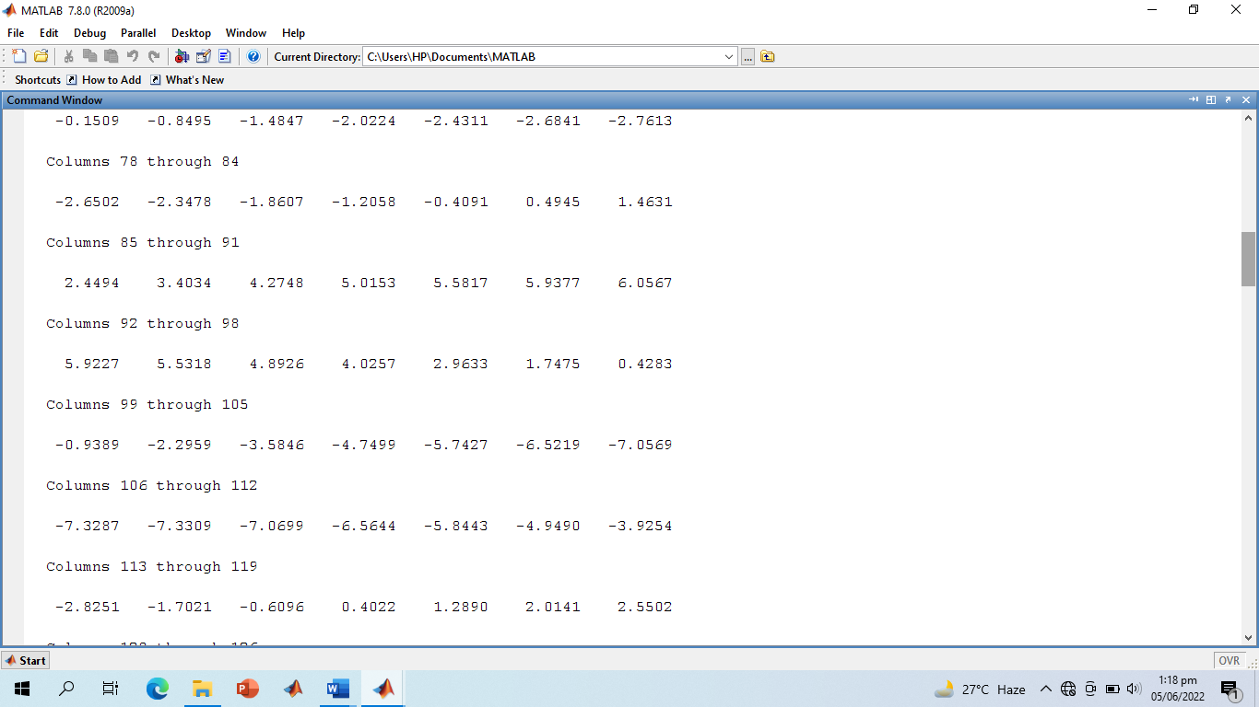

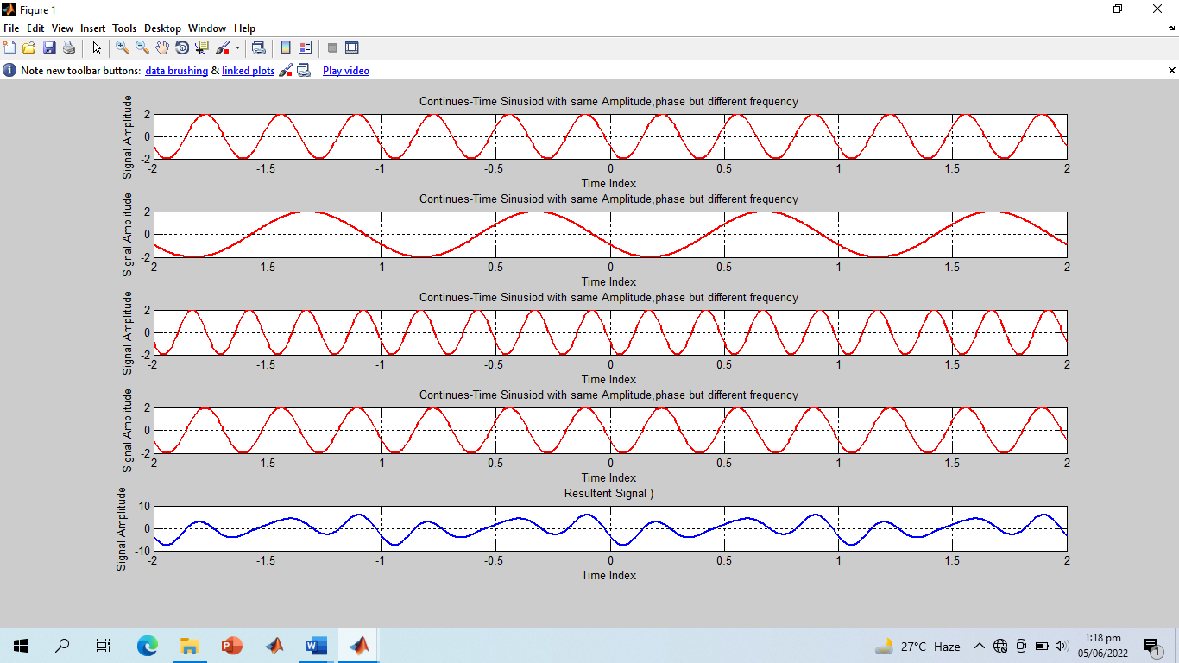

**Note:** As the frequency of individual signal 4 is more than other so the effect of that signal is more in resultant signal I,e resultant signal look like signal 4.

**-------------------------TASK 9--------------------------**

* Write a general program that takes ‘n’ sinusoids from user of same amplitude and frequency with varying phases. Take each phase from user on run time. Plot the individual sinusoids & the resultant using subplot function on same figure. Do perform proper labeling. Note: Take the amplitude and frequency given in example of case 4. Run the code for different values of n and state the result on paper.

**Screenshot of Input:**

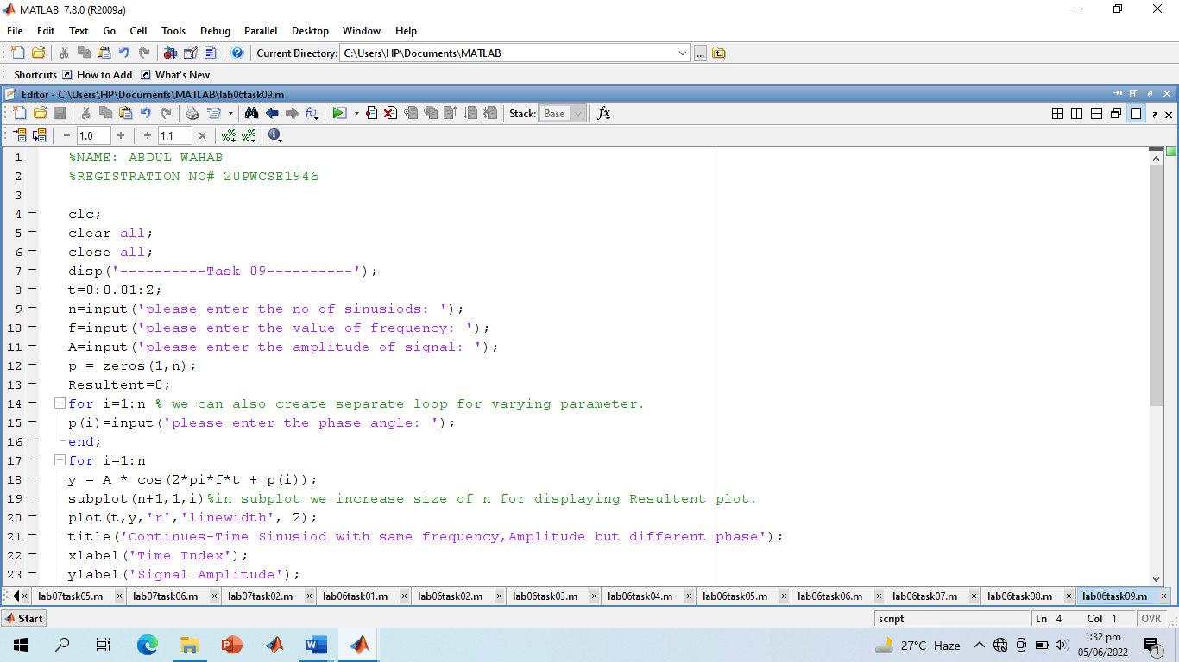

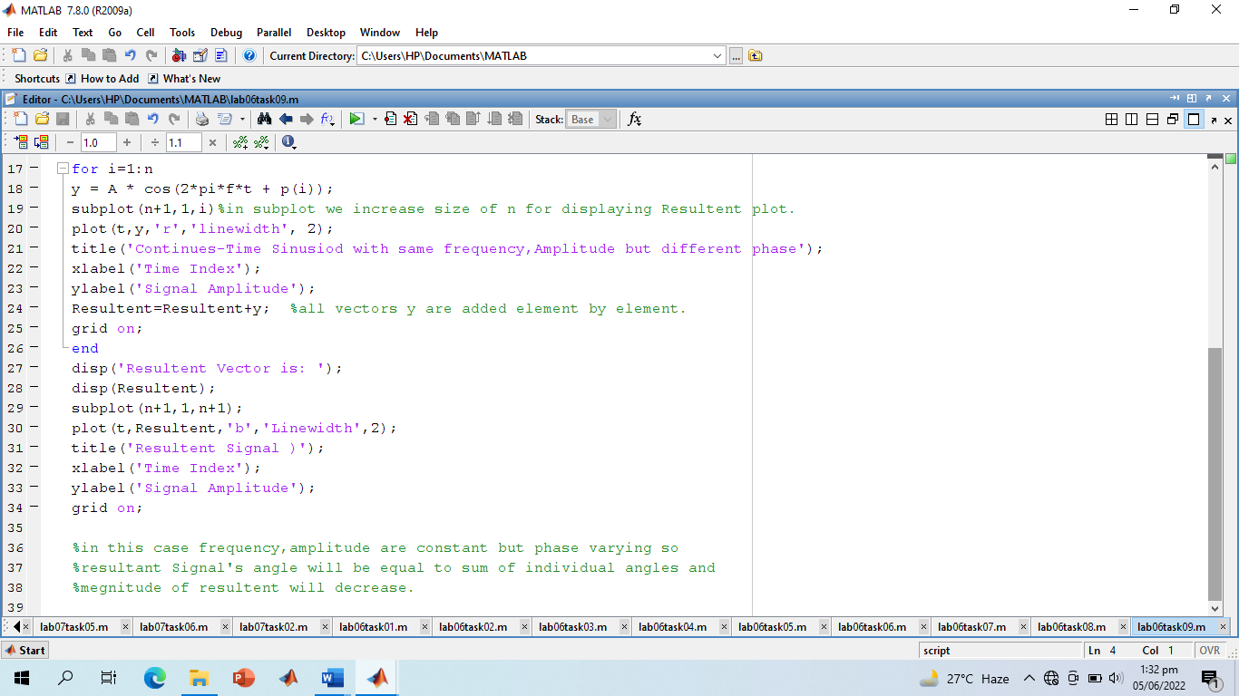

**Screenshot of Output:**

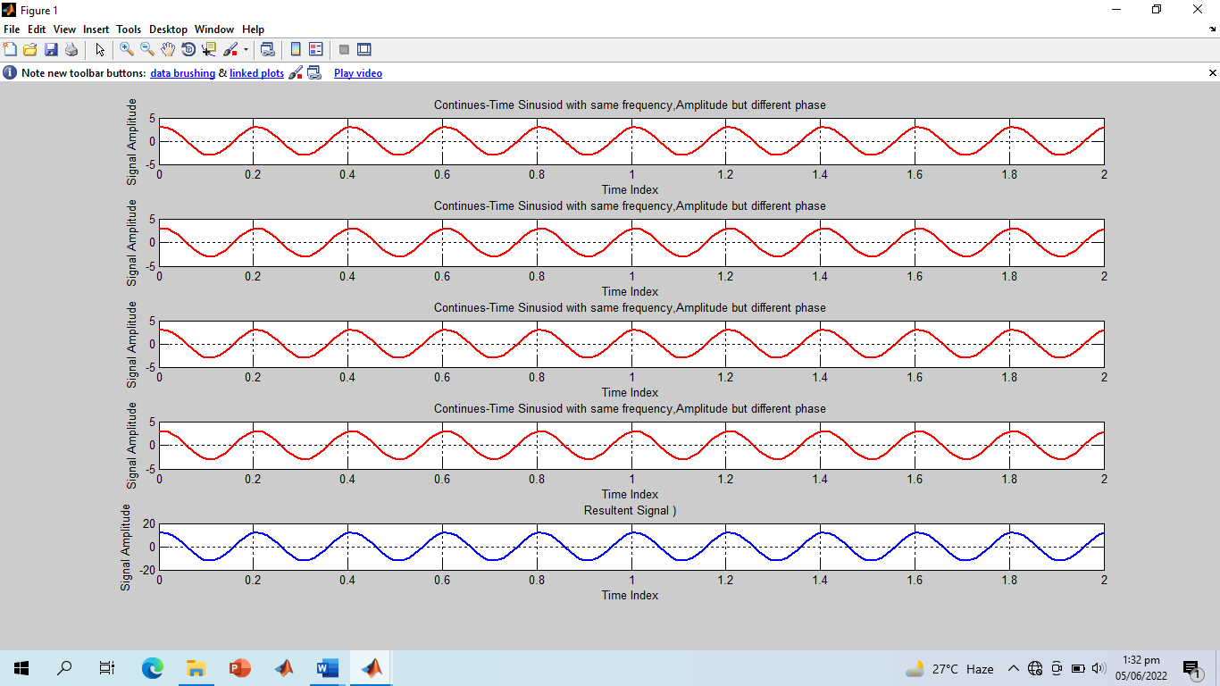

**-------------------------THE END--------------------------**